
Harbor View Huddle
HVPFO General Meeting Minutes
Friday, October 4th, 2024 8:58 AM MPR

- Presidents’ Report – Candice Kuhn and Kate Gresham
- Update
  - Safety and Security Update
    - Last meeting, we discussed campus security. Discussed e-bike safety and security. Afterward, Candice called Newport Beach Police Dept and found out and learned about our SRO – Officer Gilbert.
    - Elementary SRO Officer Gilbert
      - Is our assigned officer.
      - Also assigned to Ensign (but covers all elementary schools). He is open and willing to come visit if we ask him. They try not to have officers on campus because it tends to make kids nervous.
      - We are doing a mobile café event on October 25th where NBPD comes in and does a meet and greet with kids. Will try to get him to campus to familiarize everyone with him. Hoping to have officer or volunteer for Walk to School Wednesday.
    - E-bikes – SRO’s answer is that the community (parents) is the best resource. Talk to the kids. Over last two weeks, we’ve had fewer incidents. Principal Lempert has talked to a few about wheelies. Park Ranger was at CYC this week. He talked to kids on manmade bike jumps. Also email came out from the district on the topic.
    - Meeting with our District Board Trustee Lisa Pearson
      - District is putting protocols in place for e-bikes and security. Walk your bike on campus. Our issue is mainly CYC but that’s not school property. Lisa confirmed our concerns have been heard.
      - Campus Safety - Classroom Radio Initiative
        - Lisa confirmed that the AI cameras ($5 million project) will go in in March 2025. Cameras sense patterns. Moving forward.
    - Question/Discussion:
      - With a closed campus, how do the police get in? There is a lockbox that Fire Dept can get in. Concern over making sure they can get in to help when needed. In Irvine, police have a master key. They have a breech kit (fence cutters, etc.) to get in when needed.
      - SRO – also does family wellness checks. He is the point person for all of that.
      - AI cameras installed throughout the school. Data driven, smart cameras. Will be installed in March.
      - Why don’t we rely on a guard? The school board reviewed cost of guard v. cameras to assess best option. They did a report that assessed it all and based on that, the Board made the decision to install AI cameras for the district. Candice did speak to Lisa about it. She was going to talk to Wes, superintendent. It would need to be approved across the district. Company will monitor the AI. Mr. Lempert walked the perimeter with the company. We don’t have a ton of details but will share as needed. An armed guard would require a high insurance cost.
  - School Play - Addams Family
    - Registration Opens in November with rehearsals in December. Lorissa Brunk is our chair. Registration starts in November. For 5th and 6th grade.
    - Question: Offered to littles? No. Logistics. Late shows. Lot of rehearsals. Not a good fit.

- Financial Report – Jennifer Jackson and Ane Priyavid
- Preliminary September Reporting

- Announcements
- Book Fair – Diane Maloney SUCCESS!
- Read-a-thon – Jamie Casteneda and Laura Hoffman
  - At almost $52,000. 83% of students are registered. Opened until Sunday at midnight. Then we will shift to the incentive party and get volunteers for that.
  - Continues through Sunday Oct 6th
  - Winners will be announced Friday October 25th at Flag Deck
- Membership – Cristin Wertman and Brittany Megonigal
  - Thank you to our Volunteers of the Month! Eric C, his dad, Brandon Piersant
  - Still looking for a chair for PNO. Please let Cristin and Brittany know of anyone who would be good.
- Community Outreach – Ashley Carlton and Monica Houpt
  - National Walk to School Day Fri Oct 9th is next week, NBPD will be on campus that day (or perhaps a volunteer at Goldenrod Gate). Good reminder of wearing your helmet at Flag Deck. Walk-n-Roll theme day.
  - NBPD Mobile Café Fri Oct 25^{th.} They will arrive at 7:00am and will bring a lot of vehicles. We can open gates at 7:45am. Donuts, coffee, juice.
  - Candy will be collected for troops.
  - Confirmed that the coffee cart will be present for the holiday performance.
  - Thanksgiving Food Drive November 8-15th.
  - Common Thread shopping event on November 19th.
  - Roller skating November 13th in Fountain Valley. Give back.
- Veteran’s Day Assembly - Griffin Coon
  - Additional Recess Art - Oct 17th. For crafts to send to the troops. Sign up genius to come.
  - Candy Drive for the Troops - Bin Collection in the Office Nov 4-8th
- Communications - Griffin Coon, Stephanie Gabriel and Michele Yian
  - Please send all requests or photos to harborviewpr@gmail.com
- HV Dad’s Update – David Hekimian (absent)
  - Spooktacular – October 24th (Thursday). Costume parade, pizza, fun community event.
- Yearbook Photos
  - Preschool needs a link. Need to change Erin Palmer’s name for second grade.

Teachers Corner

- Teachers’ Report – Ms. Ericastilla – Thank you for the book fair. Quality and options were nice. Newer titles. Sharing books. Kids are excited by it. Ms. Ericastilla had kids share their favorite reading place, sharing books. Wants it to stick after RAT.
- Principal’s Report – Mr. Lempert – Impact teachers are highlighting a kid that shined for the week and get a book out of the vending machine. Every child in TK – K have an opportunity to get one by Thanksgiving. Upper grades collect Brave tickets to get a coin. Kids are leaning in. Celebrated kids that are bold in the classroom. ABC Fashion Show was this week. Great to see the engagement (of kids and parents). Leadership opportunities for our students are great. Classroom buddies are a great opportunity. ASB students selected. Working on PAL (with Ms. Danahy). Part of the experience is that you don’t always get what you want. Teachers are intentional with students in all of this. We love the buddy program. Stephanie and Griffin are planning to write about the buddy program in Greet. Send them quotes to include in the Greet article.

Open Forum

Positive Increase in Attendance – Attendance has improved. Great success. Blue Ribbon and CA Distinguished Schools awards – this is an important component. Two years ago it was at 9% (18 days or more, almost a month or more). Last year was 5%. Big improvement. Important to have kids here and be present. Of course, keep them home if sick. We are discussing the excessive absences. It helps our staff/teachers, the students. Takes time to get them integrated again. Attendance was holding us back from awards before. Don’t know what the criteria is going forward. They often looked for growth (what the state looks for). Once a month, there is a report that shows attendance. Greet Magazine is going to sponsor a treat for students to celebrate our grade levels for attendance.

Meeting adjourned. 9:39am.
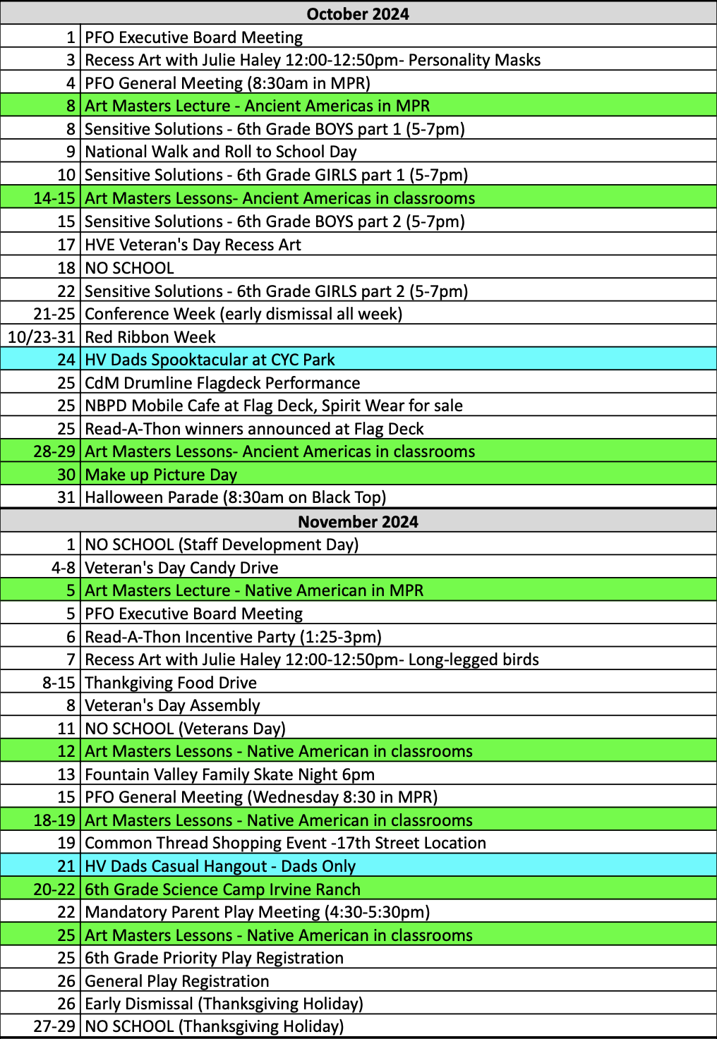
Please save calendar
to your homescreen:

Next Harbor View Huddle

Friday, Nov 15th

